ONLINE HOUSE RENTAL SYSTEM

GROUP NO 10

Members:

|  |  |
| --- | --- |
| NAME | ID |
| RAISA ZARIN | 17301072 |
| Md.Nafeur Rahman Labib | 17301147 |
| Sabah ShahNOOR Anis | 18301288 |

**ONLINE HOUSE RENTAL SYSTEM:**

**INTRODUCTION:**

Our topic is “Online House Rental System”. We plan to create this system so that it makes easier for short term tenants as well as travelers of lower budget to visit and find a comfortable place to live in without spending a huge amount of money. This also benefits Hosts/Owners who have empty spaces suitable for rent in expensive/Tourist areas.

**System Request:**

**Online House Rental System Request**

|  |
| --- |
| **Project Sponsor:** John Doe, Vice President Marketing |
| **Business Need:**  We aim to create this project for the ease of short time tenants, travelers with limited budget and for those who prefer their private space while staying abroad. We hope to make customers life enjoyable, and safe. |
| **Business Requirements:** Using the website customers should be able to view available spaces ready for rent. The main functionality the system will provide are:  1. Accommodation details. How spacious the place is and how many rooms they will be provided.  2. Actual Location and surrounding details.  3. Total expense per day and available packages provided by the owner/host.  4. The security service provided.  5. Customers can book and cancel booking any time before paying the advance. |
| **Business Value:** As our online rental system also include traveler friendly functionalities we believe that this will encourage more travelers to travel to areas that might have been too expensive for their budget or were not considered to have the best accommodation service. Also travelers that enjoy more private space as well as tenants who do not plan to stay long in a place will easily be able to find a place to their convenience in a much more reasonable price.  Conservative estimates of tangible value to the company include the following:   1. $500,000 sales from rental services provided. 2. $800,000 from short/long term tenants. 3. $300,000 from affiliated host/owners of accommodations. |
| **Special Constraints:**   * The system should be completed before holiday seasons as that is the time when house renting and booking is in demands. * In our system host/owners might apply specific manners or restrictions which might not be our management’s responsibility to handle or interfere. |

By Raisa Zarin

**Requirement Analysis:**

Functional and Non-Functional requirements of the online house rental system is given below:

**Functional Requirements:**

1. The System has to provide various searching methods such as “Quick Search” and “Search by house ID” for the house seekers/travelers to search the Rental Advertisement that resides in the database. Besides that, they can browse rental house by location.
2. House owners/seekers must register into the system to provide/search advertisements.
3. The registration forms will capture contact information, credit card information and the chosen username and password for future login/logout session.
4. House owners must post detailed information about the rental house, the security service and packages they will offer to house seekers/travelers. They must attach pictures of the house in the system.
5. The system will allow house owners to edit their contact/debit info as well as terminate their advertisement from public viewing.
6. System Admin must review all registration done in the system.
7. Admin should review and carry out online transaction before posting ads for public viewing.
8. Admin has to clear out expired ads from the system.
9. The system will create a record of house seekers/travelers purchases.
10. Admin must generate revenue reports based on the system.

**Non Functional Requirements:**

1. The system should ensure that only authorized administrators have access to the administrator subsystem.
2. System should allow only registered house owners can login to use certain services and perform certain tasks.
3. The system should update pending advertisements within 24 hours.
4. The system should be able to run 24hours without any restrictions.
5. Customer personal Information must be protected through two factor authentication.
6. System should be able to support at least 20 staffs at the same time.

By Raisa Zarin

**Use Case Diagram:**

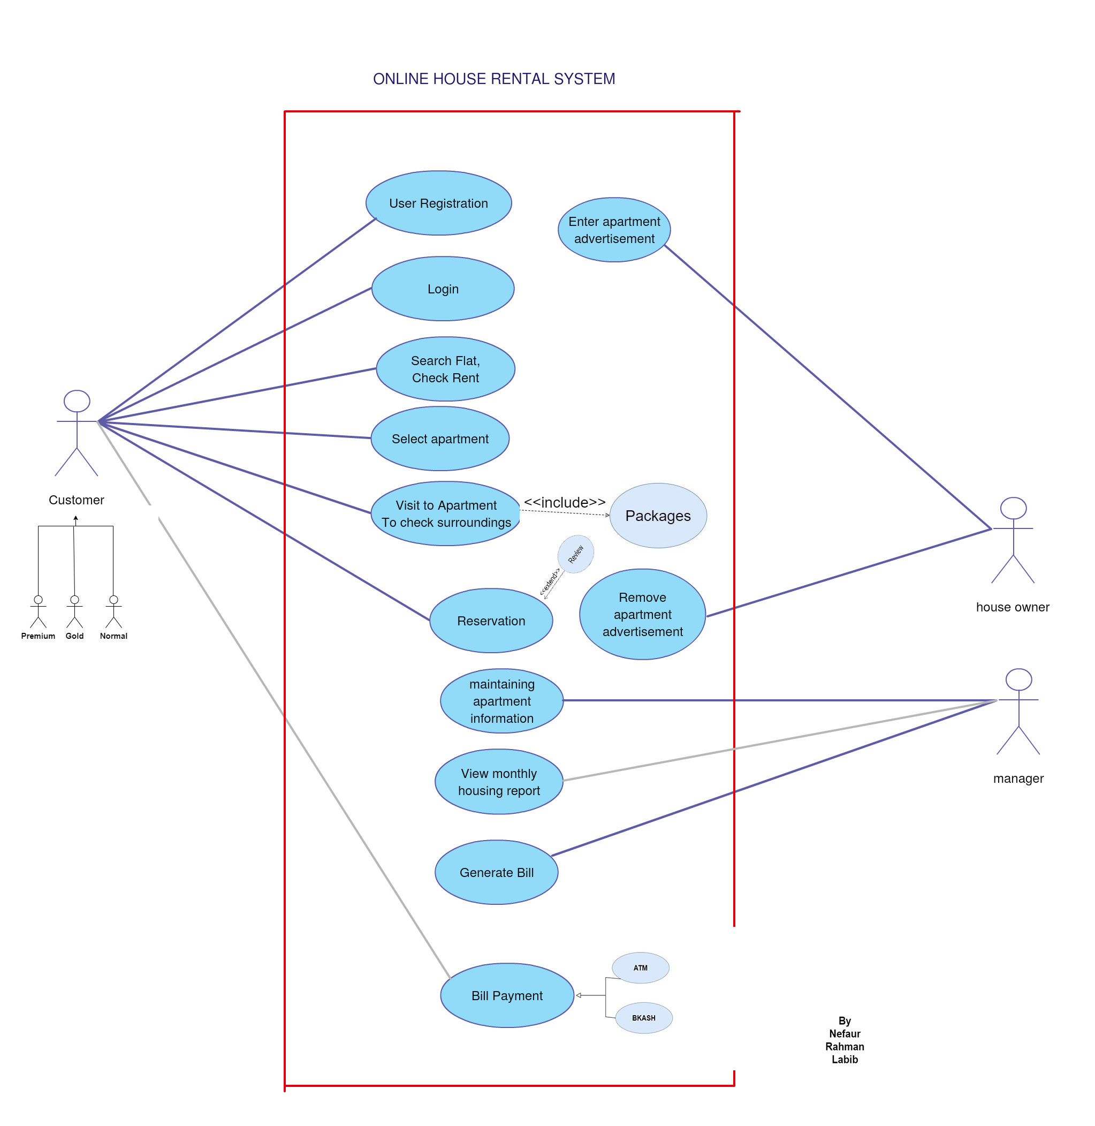

**Class Diagram:**

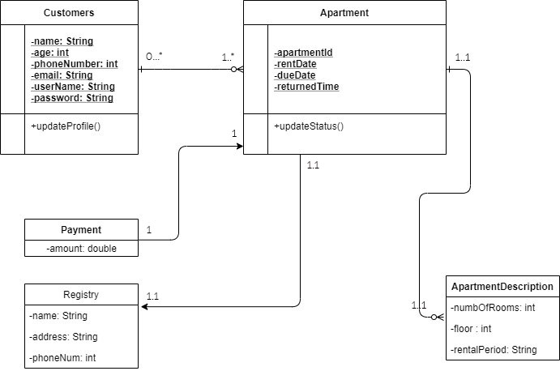

By Nefaur Rahman Labib

**Data Flow Diagram:**

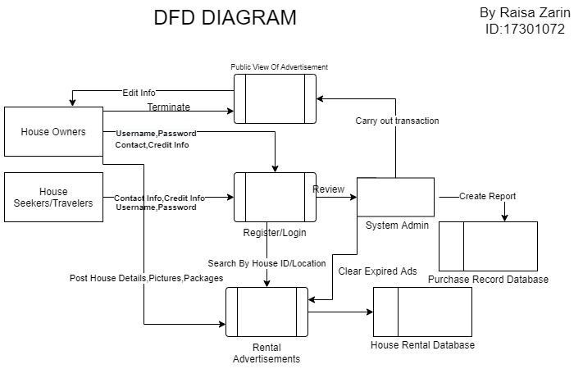

**Activity Diagram:**

#1st house owners as well as house seekers register to the system by providing contact info, credit card info, username and password.

#Next, the system admin reviews these registrations. If there are any registration errors, the process will end here.

#Then, the registered house owners will create an advertisement post including rental house information, security services, packages and pictures.

#All these infos will be stored in the House Rental Database

#Admin will review then post the ad for public viewing. If there is any invalid info then the process ends here and the ad is not posted.

#House owners can terminate their ads anytime.

#Admin will clear out expired ads from public viewing.

#Now registered house seekers can view ads by methods of quick search, search by HouseID, search by location.

#Admin will create a record of house seeker’s purchase and store info in a separate database.

#Admin will then generate revenue reports based on Purchase Record Database

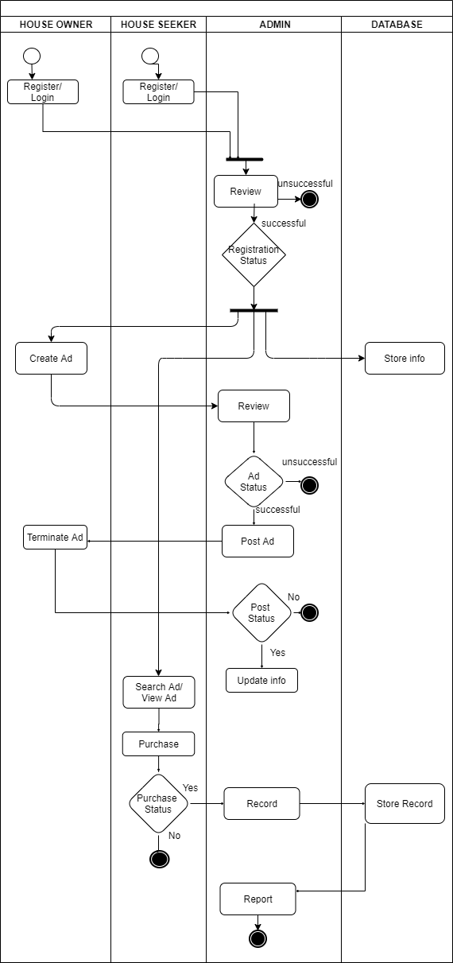 By Sabah Shahnoor Anis

SEQUENCE DIAGRAM

#Everything is same as the Activity Diagram, with the exception of 2 actors namely the house owners and house seekers as they are external to the System

#there are 2 if-else conditions required for this process

#1st house owners as well as house seekers register to the system by providing contact info, credit card info, username and password.

#Next, the system admin reviews these registrations. If any registration errors exist, the process will end here.

#Then, the registered house owners will create an advertisement post including rental house information, security services, packages and pictures.

#All these infos will be stored in the House Rental Database

#Admin will review then post the ad for public viewing

#House owners can terminate their ads anytime.

#Admin will clear out expired ads from public viewing.

#Now registered house seekers can view ads by methods of quick search, search by HouseID, search by location.

#Admin will create a record of house seeker’s purchase and store info in a separate database.

#Admin will then generate revenue reports based on Purchase Record Database.

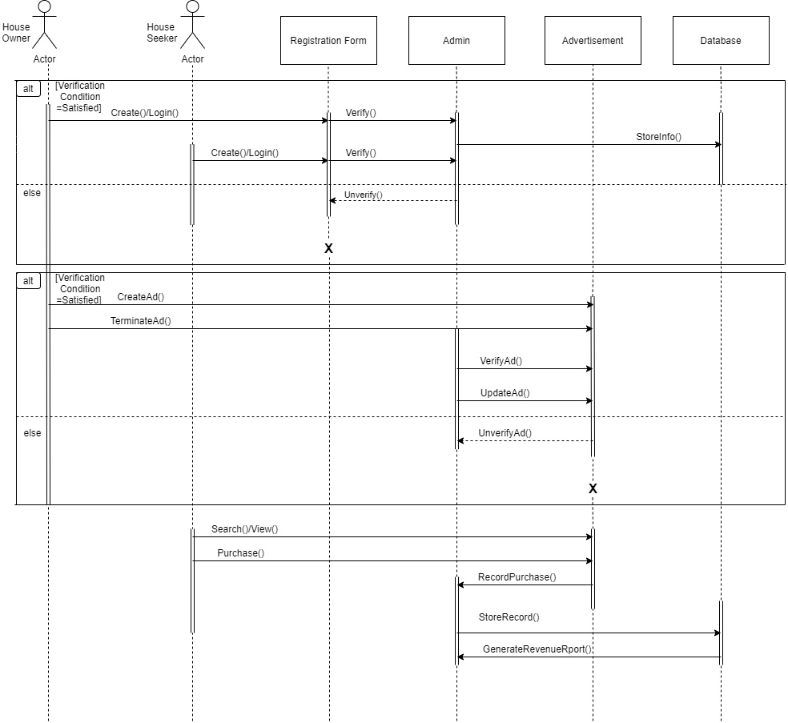

By Sabah Shahnoor Anis

**Conclusion:**

In conclusion we believe our system will ease the hassle of finding a proper place to stay significantly. This system will boost travelling as well as provide services that will be beneficial to both house owners and seekers.